Title: Data-Driven Innovation for Problem Solving

Introduction

In today's data-driven world, innovation is key to solving complex problems. Businesses and organizations are constantly seeking new ways to leverage data to gain deeper insights and make informed decisions. In this document, we will explore how data segmentation by time periods and countries can be used as an innovative solution to address specific issues.

Data Set Link : <https://www.kaggle.com/datasets/chakradharmattapalli/covid-19-cases>

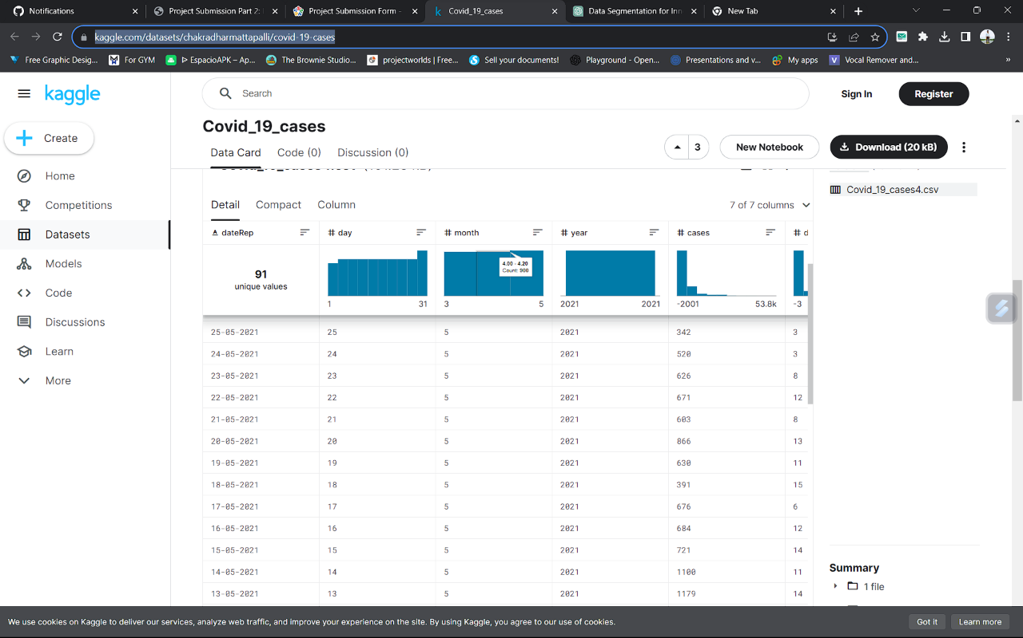

Problem Statement

Define the problem you aim to solve. For instance, let's consider a retail business facing the challenge of declining sales. To solve this problem, we will focus on data-driven innovation.

Data Segmentation

1. Time Periods:

Daily Segmentation: Analyzing data on a daily basis can provide insights into daily sales trends. This can help identify specific days of the week or times of the day when sales are consistently lower.

Weekly Segmentation: Weekly segmentation can help identify sales patterns and trends over different weeks, allowing for the assessment of sales performance based on changes in marketing strategies or external factors.

Monthly and Quarterly Segmentation: These time periods can help in assessing longer-term trends, seasonal variations, and the impact of marketing campaigns.

2. Countries:

Geographic Segmentatio: Dividing data by countries can help identify regional variations in sales. This can be useful for tailoring marketing and sales strategies to specific regions.

Cultural and Economic Factors: Different countries have unique cultural and economic characteristics that can impact sales. Segmenting data by country can help in identifying the influence of these factors.

Innovative Data Analysis Techniques

1. Predictive Analytics: By analyzing historical data segmented by time periods, predictive analytics can be employed to forecast future sales trends. This can assist in planning inventory and staffing more effectively.

2.Customer Segmentation: By analyzing data by country and time periods, businesses can create customer segments based on buying habits. Tailored marketing campaigns can be then be designed for each segment.

3. A/B Testing: By comparing the performance of different strategies over time or across countries, businesses can use A/B testing to determine the most effective approaches.

Data Visualization and Reporting

To make the most of this innovative data segmentation, businesses should invest in robust data visualization tools and reporting systems. Dashboards and reports can provide a clear and concise view of the insights gathered from the segmented data. These visuals should be designed to highlight key performance indicators for both time periods and countries.

Benefits

- Enhanced Decision-Making: Data segmentation allows for more precise decision-making based on in-depth insights.

- Improved Resource Allocation: Businesses can allocate resources more effectively based on data-driven insights.

- Enhanced Customer Experience: Tailored marketing and sales strategies can improve the customer experience, leading to increased loyalty and sales.

Please provide specific data and details related to your problem statement to receive a more detailed analysis and design for implementing data segmentation for innovative problem-solving.

**Source Code:**

import pandas as pd

# Load your sales data into a DataFrame

data = pd.read_csv('sales_data.csv')

# Segmentation by time periods (e.g., monthly)

data['OrderDate'] = pd.to_datetime(data['OrderDate']) # Convert date column to datetime

data['Month'] = data['OrderDate'].dt.to_period('M') # Extract month from date

# Segmentation by countries

country_groups = data.groupby('Country')

# Calculate total sales per country

country_sales = country_groups['SalesAmount'].sum()

# Print the results

print("Monthly Sales:")

print(data.groupby('Month')['SalesAmount'].sum())

print("\nTotal Sales by Country:")

print(country_sales)

**Conclusion**

Data segmentation by time periods and countries is a powerful and innovative solution for problem-solving. By leveraging this approach, businesses can gain deeper insights into their operations, identify trends and patterns, and make informed decisions that drive growth and success.